The TX-130 Saber-class Fighter Tank in Star War: Legion is a Heavy-type unit like none seen before. It has unique attributes and keywords that truly make it an unstoppable force to be reckoned with, some of which I will list below, and detail their implications:

* Red Dice Saves: as opposed to previous heavy units that statistically save only 17% or 33% of the time, the Saber tank saves at least 50% of the time and up to 67% of the time with surge tokens it has access to
* Outmaneuver: The saber tank is one of very few heavy units that can spend dodge tokens to cancel the critical hits that get past it’s armor
* Access to Exemplar: Padmé generates a lot of tokens and through her exemplar ability she can share her tokens to other units including aim, dodge, and surge tokens. Suddenly, the saber tank is able to guarantee more of it’s dice land, more damage gets through from its shots, and damage against it is mitigated.
* Access to Authoritative: When Padmé issues orders, she can issue her own order to any other unit, including the tank. So if you equip the Saber Tank with Linked Targeting Array, it will automatically have an aim token most every round.

Below I will share a few lists that utilize the Saber Tank in different ways.

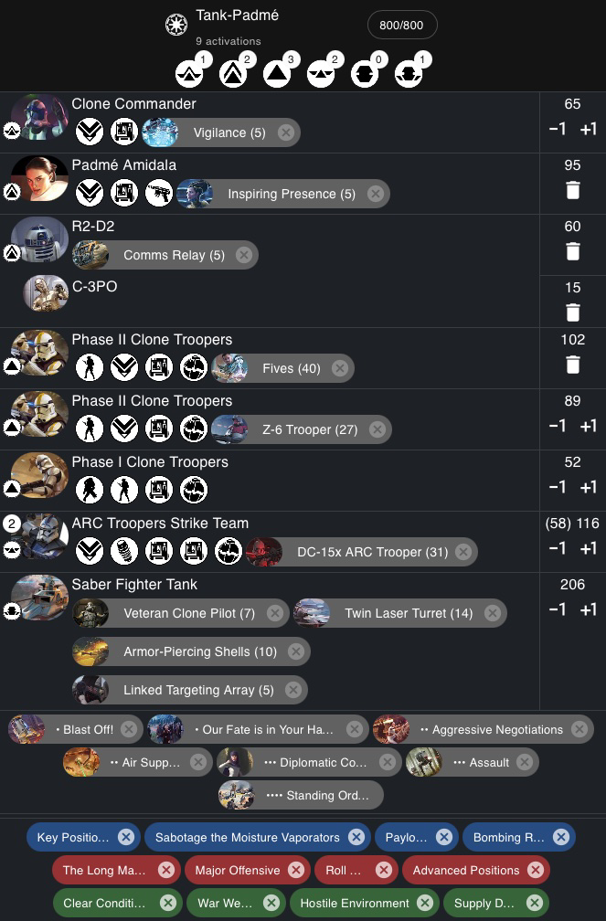

This list prioritizes getting an order onto the Saber tank while still allowing units like Padmé and R2 to play very dynamic cards. Padmé, C-3PO, and the clones can all stack tokens and the saber can make defense rolls with access to 3+ dodges, attacks with the same amount of aims, innumerable surges, and even the dreaded bogeyman of tokens: the standby token.

R2 can still threaten secret mission, Padmé and the support clones can still be great token-batteries, all dedicated to keeping the tank alive and making sure it hits hard with it’s attacks.

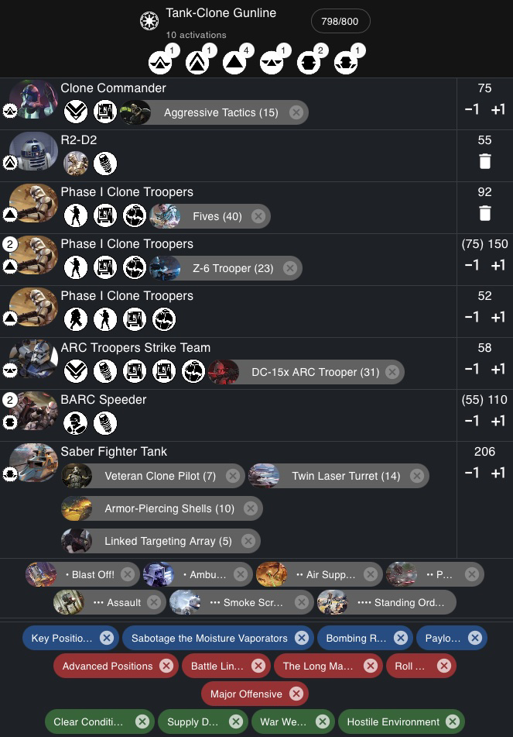

This list is more of a traditional gunline, it provides beefier clones with heavies than the first list, but also sacrifices Padmé’s exemplar perks. As a result you get an additional activation without sacrificing too much in firepower, but the tank overall is more susceptible to damage and poor attack rolls.

All-in-all, the tank is incredibly versatile. In light of today’s melee meta, some strike teams and heavies can be changed out to wookiees for additional melee support. The one shortfall of the tank is the faction it’s in. The tank needs support pieces to make it viable in a faction that - while running one heavy unit - can barely get to 9 useful activations. In the future however, we hope to see more diversity in Saber Tank lists.